# Name: Ramila Jane B. Abobo Assignment #1 - Introduction to Python

Section: CS3C

Introduction to python  
●       Features of Python Language

* Python Language has a concepts of Encapsulation, Inheritance, and Polymorphism that can make it easy to write code that reusable and can make a maintain in python. Python is an easy to read, it can compare the python of the code into the simple English words also It was an open source that free to use even for commercial purposes and in their official websites. Python is a dynamic language, It is not requiring to declare the any type of variable. Also, Numerous platforms and operating systems, such as Windows, macOS, Linux, etc., are compatible with Python. Because of this capability, Python code can execute consistently on multiple platforms, allowing programmers to create it once and have it run on multiple systems.

●     Advantages of Python

* User-friendly- Python provides simple, user-friendly data structures that make managing and manipulating data easier.
* Open source software and a large, dynamic community- Python is an open-source software with an engaged community that actively participates in its development and offers assistance.
* Internet of Things (IoT) opportunities- Python's simplicity and versatility make it a popular choice for Internet of Things applications.
* Ideal for prototypes- Python's brief code allows developers to quickly prototype solutions using less code.
* Presence of third-party modules- The abundance of third-party modules and libraries available for Python expands its capabilities for a wide range of applications.

●       Disadvantages of Python Programming Language

* Memory consumption- Python can use a lot of memory, particularly when executing complex algorithms or working with big datasets.
* Lack of strictness- The versatility of Python can have drawbacks at times. It might result in code that is challenging to comprehend and maintain, even while it can be excellent for quick development and experimentation.
* Steep learning curve- Even while Python is widely regarded as a reasonably simple language to learn, freshmen may nevertheless face a challenging learning curve, particularly if they have never programmed before.

●       Applications of Python Programming Language

* Education
* **Prototyping**
* Graphic design, image processing
* Games, and scientific/computational applications
* Operating systems
* Enterprise and business applications

●       What is Python?

* Python is a computer programming language often used to build websites and software, automate tasks, and conduct data analysis. Python is a general-purpose language, meaning it can be used to create a variety of different programs and isn’t specialized for any specific problems. This versatility, along with its beginner-friendliness, has made it one of the most-used programming languages today. This high-level, interpreted programming language has dynamic semantics and is object-oriented. Its dynamic typing and dynamic binding, along with its high-level built-in data structures, make it an appealing language for Rapid Application Development and for usage as a scripting or glue language to join existing components.

●       Why Python?

* Python is a very simple programming language that even non-programmers can pick up quickly and use without much difficulty. Its streamlined English-like grammar, which highlights innate languages and guarantees a simple learning curve for all, is why many find it useful.

●       How to install Python?

* Python Installation on Windows
* Step 1: Select Python Version
* Step 2: Download Python Executable Installer
* Step 3: Run Executable Installer
* Step 4: Add Python to Path (Optional)
* Step 5: Verify Python Was Installed on Windows
* Step 6: Verify PIP Was Installed
* Step 7: Install virtualenv (Optional)
* Download Pydroid 3 – IDE for Python 3 app from Play store
* To install Pydroid app go to play store link here Pydroid 3 – IDE for Python 3
* After installation is complete, Run the app and it will show as installing python.
* Wait for a minute and it will show the ide. Here you can enter the Python code.
* Click on the yellow button to run the code.

●       How to install PyCharm  
(IDE)?

* How to Install Pycharm on Windows?
* Download the PyCharm installer for Windows. Download the PyCharm installer for Windows from its official website, jetbrains.com. ...
* Install PyCharm on Windows. ...
* Reboot & Launch PyCharm. ...
* Create your First Python Project. ...
* Install Python Interpreter If Not Installed. ...
* Install Packages and Libraries.

●       Basic Python Program  
Structure

* 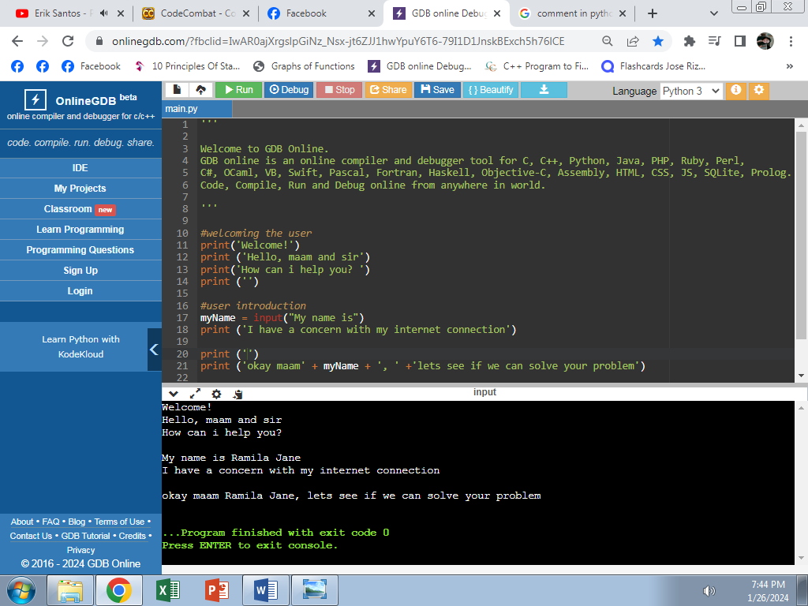

●       Basic Python Program  
Explanation

* In this python it shows a simple program that can easily to understand especially to the new in this language. In this program it indicates the conversation between the user and agent. Using the “print” function, it is used to print the message in the screen directly. Also, in “input” function, it is requesting for user input. This symbol “#” is a comment which is a guide for the programmer to avoid a confusion in the program.